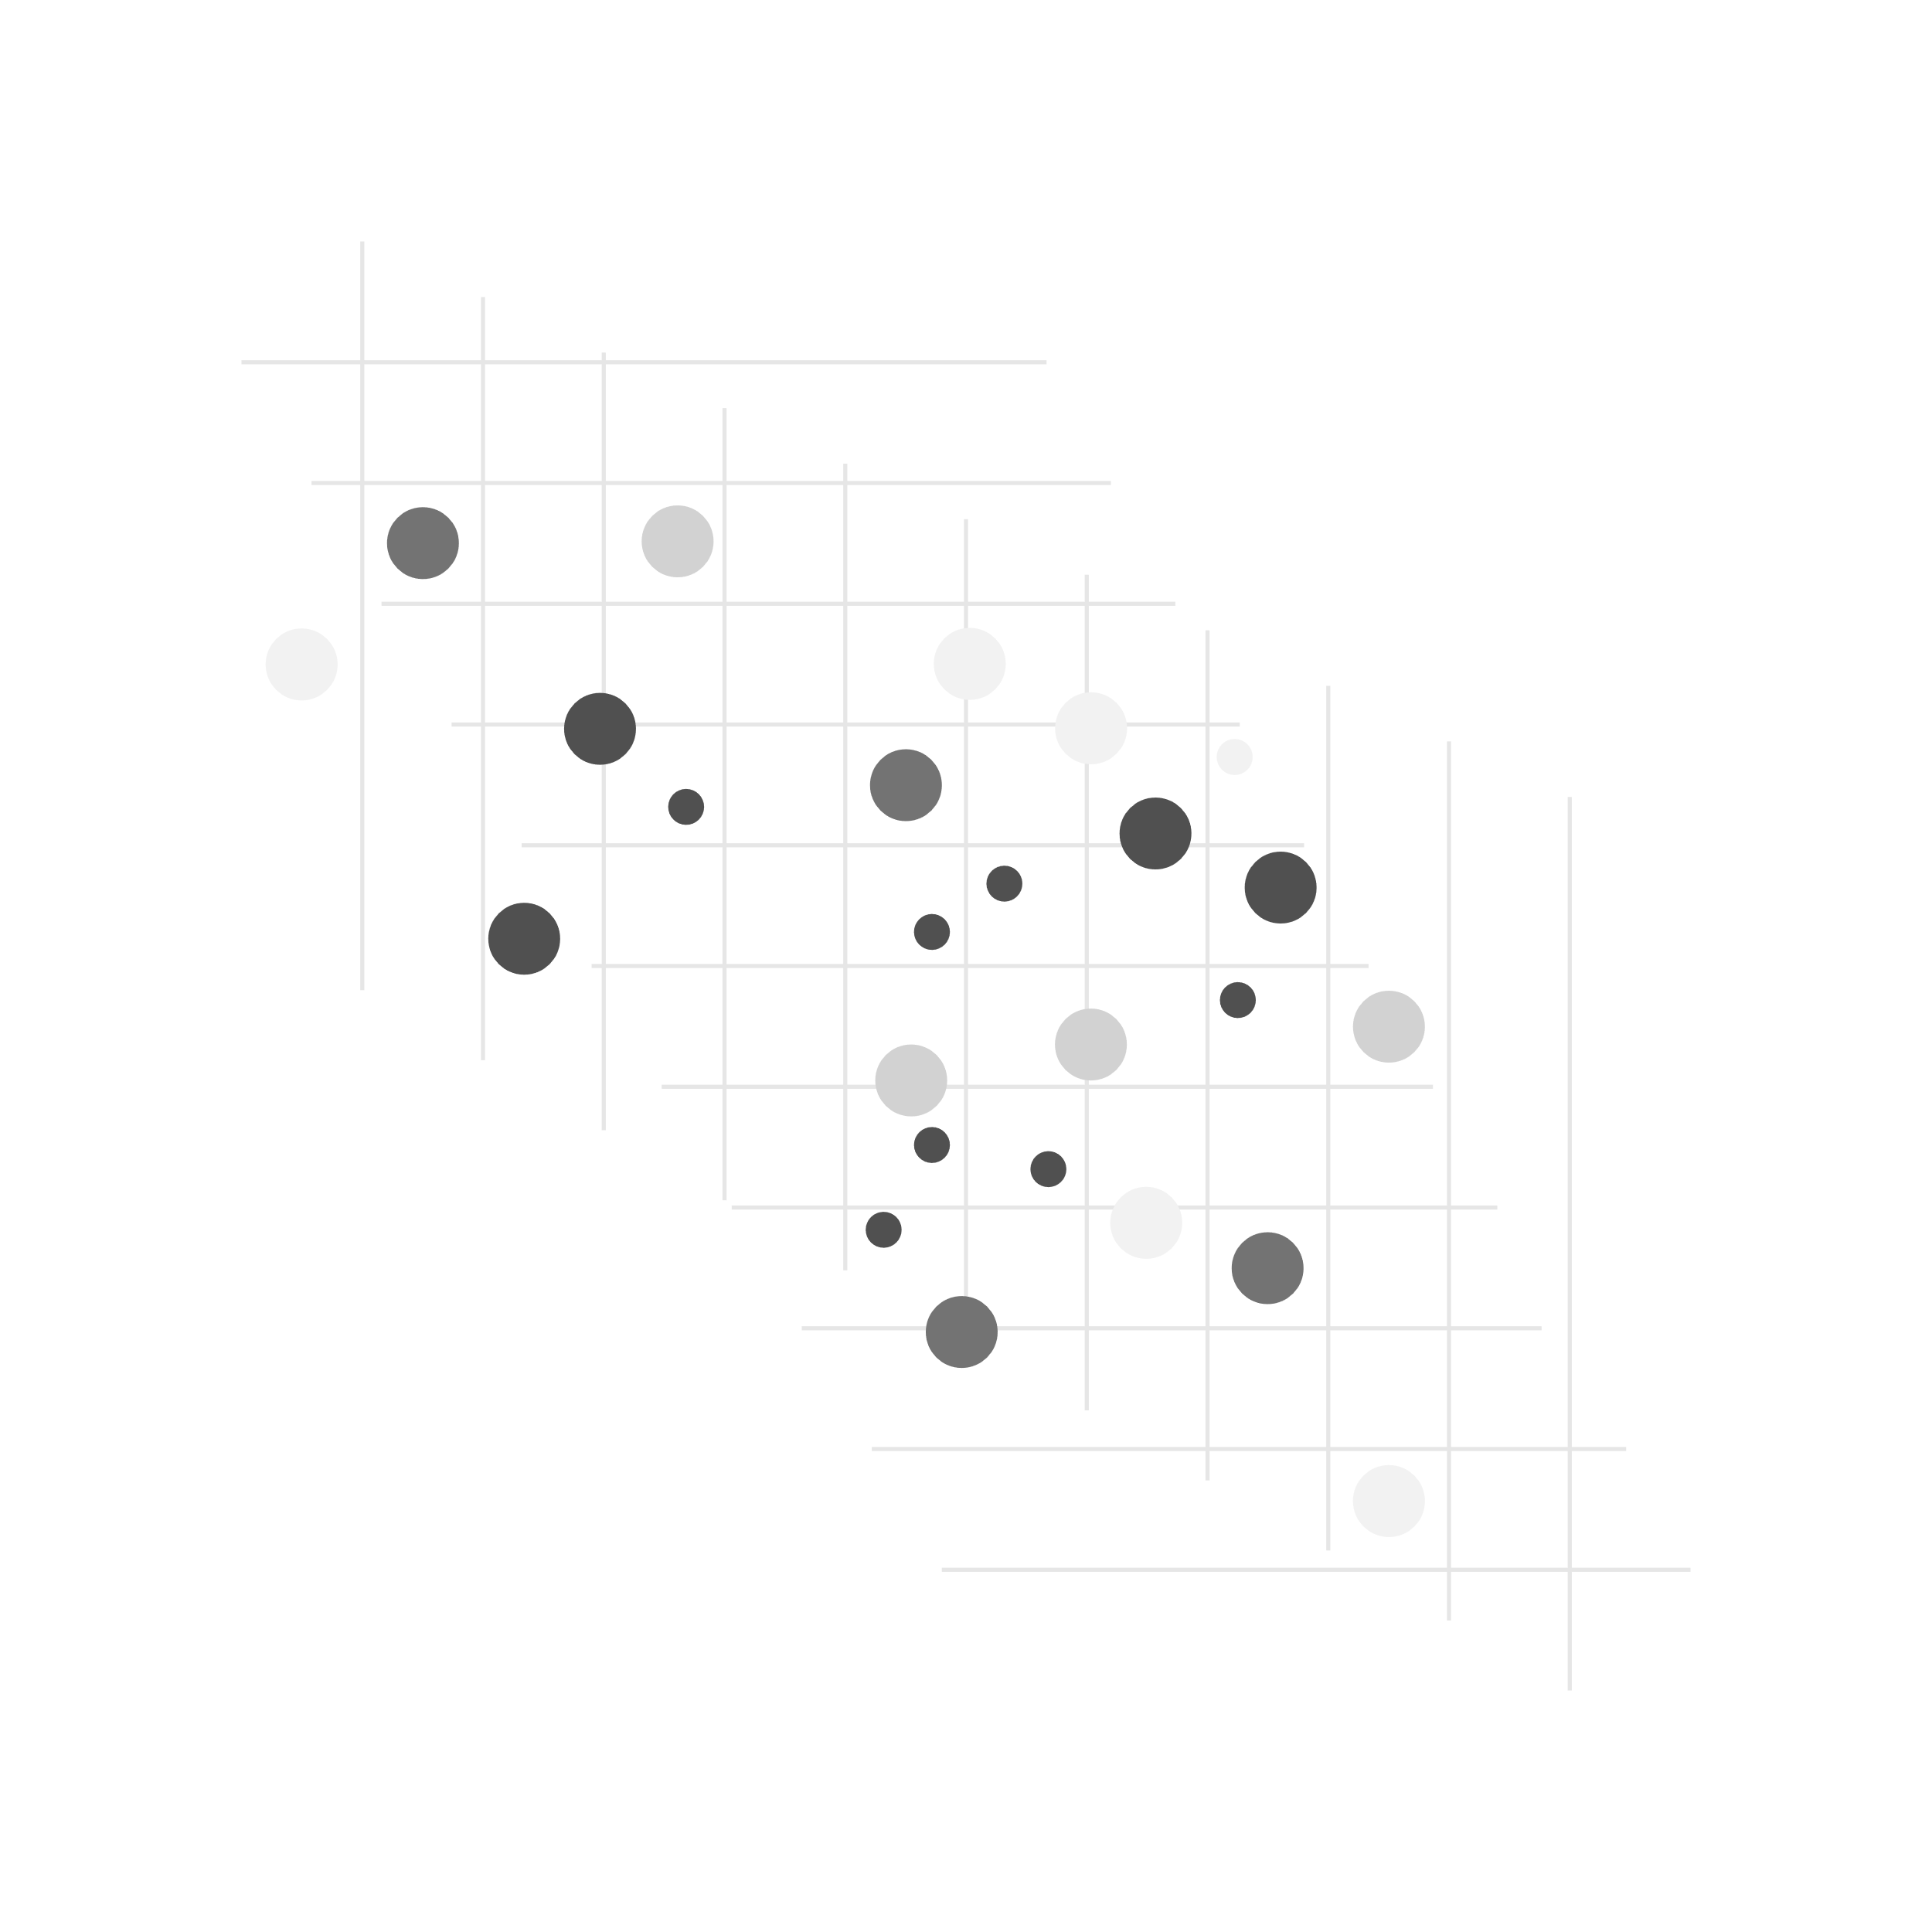

|  |  |
| --- | --- |
| Assorted circles | Restaurant booking SaaS |
|  |  |
|  | **Program:** BSc in Computing (Application Development) |
|  | **Course:** Undergraduate Research Project (CLD6001) |
|  | **Supervisor:** Mr. George Prokopakis |
|  | **Student Name:** Alex Zakas |
|  | **Student ID:** AZ101952 |
|  | One solid circle, one ring, and one circle filled with diagonal lines |



Contents

Introduction: 2

SaaS Definition and booking systems: 2

Web Application: 2

Development Method: 4

Project Timeline: 4

Conclusion: 5

Refrences 6

# Introduction:

Due to the progression of online platforms, the last decade brought many changes that shifted the reservation market (Boto-García, et al., 2021). The volume growth of SaaS systems has allowed organizations to adopt and make quick decisions more easily than ever. This is reinforced by the fact that most SaaS systems have a negligible acquiring cost due to most providers operating on a subscription-based model, minimizing the risk of mistakes that may lead to loss of investments. (Mero, et al., 2022)

This project will produce a SaaS web application designed for restaurant table booking. It will present different development process designs and implementation approaches used in modern development environments

# SaaS Definition and booking systems:

To start off, by definition SaaS (Software-as-a-Service) is a cloud-based software that provides access to third-party participation by operating in a multi-tenant architecture. Businesses can access the application remotely while they resign no responsibility for the development or maintenance of the application. (Oliveira, et al., 2019 ) This however can bring security downsides due to client outsourcings, prominent end-user accessibility, and host requirements conflicts. (Yassin, et al., 2022) Another problem with booking applications specifically, is the generalization of their function. Since organization requirements oftentimes conflict with one another (Yassin, et al., 2022). Modern applications need to be flexible toward the administration and reservation efficient enough to meet most organization criteria. The design of the reservation also should be understandable for the end user, improve workflow, and provide more useful functionalities to hosts. (Murin, et al., 2021)

# Web Application:

SaaS applications follow a multi-tenant architecture, where one instance of the application can serve multiple customers (tenants) at once. This is done to preserve hardware resources and manage/customize the application more easily. (Grill, 2020)

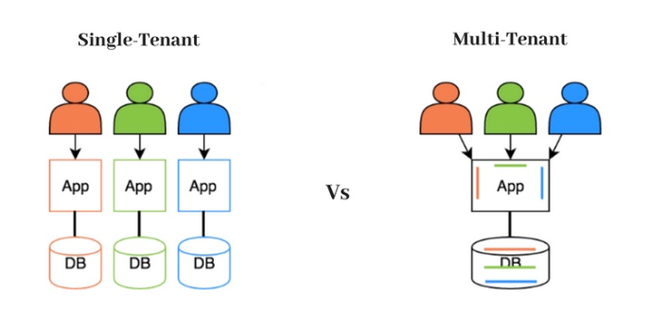

Figure 1 Graphic by Lakshay Suri.

The three main models of multi-tenancy consist of a single application with a single database, a single application with multiple databases, and multiple applications with multiple databases. Where depending on the model, changes the development method (Bigelow & Gillis, 2022)

For the database management, there are two options, SQL, or NoSQL databases. NoSQL databases, such as MongoDB, serialize objects into paragraphs instead of mapping them with tables and rows. This allows for better performance since serialized objects are stored more easily than complicated joins of multiple queries. However, their disadvantages draw, with data updates and versioning. If, for example, a region suddenly changes its name, every object in the database would require to be updated, and if the application upgrades into a new version, previous object versions may still coexist inside.(Smith, 2022)

For the back-end development, most modern applications are being created inside a framework, since they provide a more coherent platform, with more design implementations for different development approaches. ASP.Net, created by Microsoft, for example, is optimized for cloud-based hosted systems. (Smith, 2022) It operates in an MVC (Model View Controller) design pattern where user actions are managed by a Controller, and together with a set Model, they display the end result from a View to the user. This attains Separation of Concerns, simplifies the development, and boosts overall performance (Smith, 2022). Django on the other hand, created by Lawrence, was made to meet short deadlines while convening high development demands. It scales down the difficulty and allows for component reusability, by a system called DRY (Don’t Repeat Yourself) that comes with ready-to-use assets like Sign-Up structures, authentication, Database Connections, etc. (W3Schools, 2022). Another example with Node.js which uses an event-driven architecture that operates continuously without pausing for requests. This is done to make Node.js fast and lightweight when dealing with data-intensive applications, however, it is hard to work with relational databases and perform well with CPU-intensive tasks.

The same rule applies to the front end. Most interfaces and UI components are developed inside a framework, like for example React.js, where its primary role is to operate the View layer of the MVC.

# Development Method:

There are several development methods, each serving different purposes. The Agile methodology, popularized by the Manifesto for Agile Software Development in 2001, which despite its name is not an actual methodology but a set of values, ideas, and results, with the goal of making the process more flexible. The Waterfall model follows a breakdown of the process into smaller phases and moves only when a phase is done. There is DevOps deployment, a process followed for the deployment and maintenance of the system which is described as "a set of practices intended to reduce the time between committing a change to a system and the change being placed into normal production while ensuring high quality" (Bass, et al., 2015).

# Project Timeline:

This project will pursue a mix of key features from multiple models that will be accommodated, as the development goes on. For starters, the project will follow a rough timeline pinpointing the most important phases separated into 4 categories, research, development, testing, and documentation.

# Conclusion:

Software as a Service (SaaS) is a revolutionary technology that has transformed the way that businesses and consumers interact with web applications. With SaaS, businesses are able to purchase software on a subscription basis, allowing them to scale their software needs up or down as needed, without the need for additional hardware or infrastructure. This is particularly beneficial for smaller businesses, who can now access the same software as larger organizations at a fraction of the cost. SaaS offers a wide range of advantages to businesses, such as improved scalability, cost savings, and enhanced security. Additionally, consumers are now able to access software applications with just a few clicks, allowing them to gain access to the latest technology without the need to purchase or install the software themselves. SaaS is revolutionizing the way businesses and consumers interact with software, and is quickly becoming an essential tool for any organization.

# References

Bass, L., Weber, I. & Zhu, L., 2015. *DevOps: A Software Architect's Perspective (SEI Series in Software Engineering).* 1st ed. Sydney: Addison-Wesley Professional.

Bigelow, S. J. & Gillis, A. S., 2022. *techtarget.com.* [Online]   
Available at: https://www.techtarget.com/whatis/definition/multi-tenancy  
[Accessed 2022].

Boto-García, D., Zapico, E., Escalonilla, M. & Baños Pino, J. F., 2021. Tourists’ preferences for hotel booking. *International Journal of Hospitality Management,* Volume 92, pp. 1-10.

Grill, P., 2020. *sophilabs.com.* [Online]   
Available at: https://sophilabs.com/blog/django-tenant-schemas-multi-tenant-application  
[Accessed 15 May 2020].

Mero, J., Leinonen, M., Makkonen, H. & Karjaluoto, H., 2022. Agile logic for SaaS implementation: Capitalizing on marketing automation software in a start-up. *Journal of Business Research,* Volume 145, pp. 583-594.

Murin, M., Jakab, . F. & Michalko, M., 2021. *2021 19th International Conference on Emerging eLearning Technologies and Applications (ICETA).* Košice, Slovakia, IEEE.

Oliveira, T. et al., 2019 . Understanding SaaS adoption: The moderating impact of the environment context. *International Journal of Information Management,* Volume 49, pp. 1-12.

Smith, S. “., 2022. Architect Modern Web Applications with ASP.NET Core and Azure. In: M. Wenzel, ed. *Architect Modern Web Applications with ASP.NET Core and Azure.* Redmond, Washington: Microsoft Developer Division, .NET, and Visual Studio product teams, pp. 77-78.

Smith, S., 2022. *Overview of ASP.NET Core MVC.* [Online]   
Available at: https://learn.microsoft.com/en-us/aspnet/core/mvc/overview?view=aspnetcore-7.0  
[Accessed 2022].

W3Schools, 2022. *w3schools.* [Online]   
Available at: https://www.w3schools.com/django/django_intro.php  
[Accessed 2022].

Yassin, M., Ould-Slimane, H., Talhi, C. & Boucheneb, H., 2022. Multi-Tenant Intrusion Detection Framework. *IEEE TRANSACTIONS ON SERVICES COMPUTING,* 15(5), pp. 2925-2938.